DISTRICT INSTITUTE OF EDUCATION AND TRAINING MANGALORE
KALIKACHETHARIKE TRAINING
CLASSES 4 TO 9
VENUE: SHAKTHI RESIDENTIAL SCHOOL SHAKTHINAGAR MANGALORE
DATE: 6-4-2022 TO 8-4-2022
REPORT

All the trainees from 34 educational districts assembled in the Shakthi Residential School Hall. After the registration at 10.00 am inaugural function started.
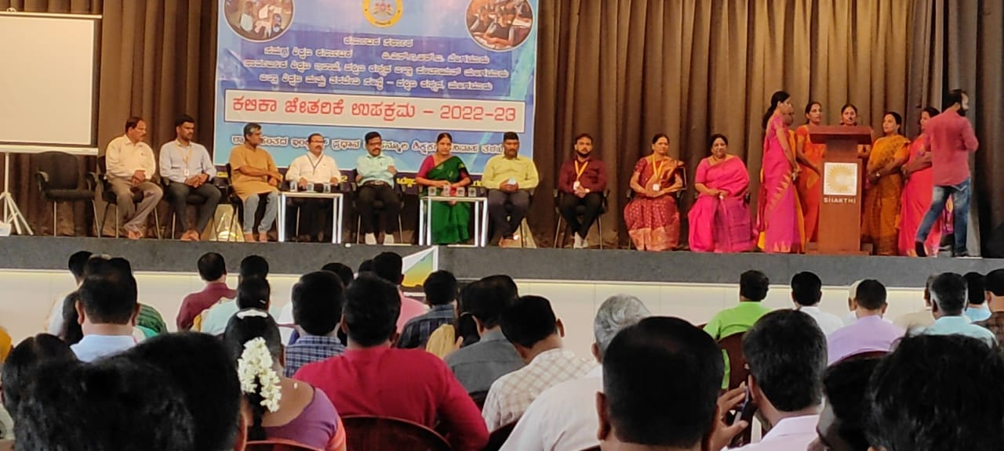
Smt. Geetha Shetty, nodal of Kalika Chetarike, anchored the whole program. Smt. Rajalakshmi, DDPI Development and Principal DIET Dakshina Kannada, spoke about the training and made the welcomed the gathering. Mr. Cypriyan Monteiro, Joint Director, inaugurated the programme and told the importance of Kalika Chetarike and inspired the teachers to make this programme a successful one. Mr. Stany Tauro,the president of high school teachers association, asked the teachers to make this programme available to the children by hard efforts. Mr. Sudhakar DDPI Dakshina Kannada, delivered the presidential speech. Mr. RamachandraGiri from Azim Premji Foundation,Mr. Ramesh, Shakthi residential school also witnessed the program.Mr. Prithvi Raj, Principal PU College Shakthi residential school, Gave the instructions about dos and don’ts in the school premises.Mr. Gururaj, DIET lecturer, proposed the vote of thanks. Then left for the break. After having kokum Kashaya, once again trainees assembled in the hall.
Before Going to lunch Mr. Vijay Kumar, RP, discussed about the Education before and after COVID, he continued the session with question and discussion about study gap of 18 months. Trainees pointed out many things about child behavioral changes. Then he explained the need of KalikaChetaharike upakrama in every class. He introduces the topic of KalikaChetaharike Upakrama 2022-23. After the session trainees had lunch. Then session continued in different classes.
CLASS 4 and 5
After the general class on Kalikachetharike program Ice breaker activity was done by RP Nirmala Wilma and teachers were divided 8 groups. Then RP Subramanya KN made the participants to participate in the discussions on ENK by using PPT. Elicited responses on its nature & approach progression, segments, LS&RW, concept of Phonics, sight words & word families & its adaptation in 4th & 5th.
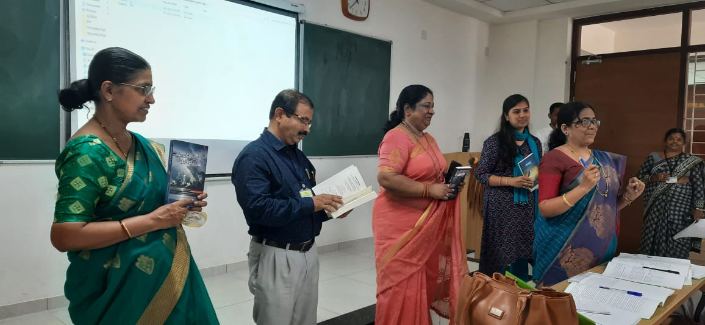

Then teachers were made to read the segment wise LOs. This class was taken from Ms. Nanda Esther. Then showed the TH and SW parts of a segment and familiarized them with the rationale, design, arrangement of activities. Participants read the ‘Note to the Teacher’ and ‘classroom instruction part’ in the TH individually and discussed their understanding in the group and shared it with the large group.
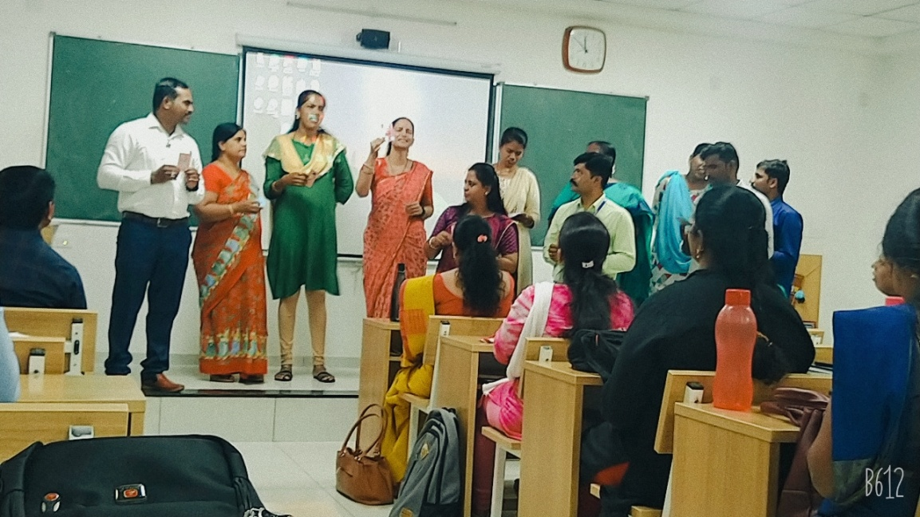

On Day 2 Recap and reflection of the different topics covered on Day 1 was conducted. Facilitator MS. Nirmala Wilma demonstrated the segment Story Toto and the cap’. The teachers demonstrated the story in groups. Feedback was given to each group about the presentation.

Facilitators Ms. Sumana, Ms. Rekha Shet and Ms. Praveena Kumari demonstrated the segments Rhyme, Language game and Concept presentation to the larger group. Then Teachers were made to read out all the steps related to the segments and each group presented one each segment. Feedback was given to each group about the presentation.
On Day 3 Recap and reflection of the different topics covered on Day 1 was conducted. Then RP Mr. Subramanya KN demonstrated the Level 1 and 2 RW activites: The letter sound combination, word families, sight word, Blends, diagraph, long vowels and word families. He also demonstrated the way of reading sentences. The different groups were made to demonstrate the RW activities. Feedback was given to each group about the presentation.
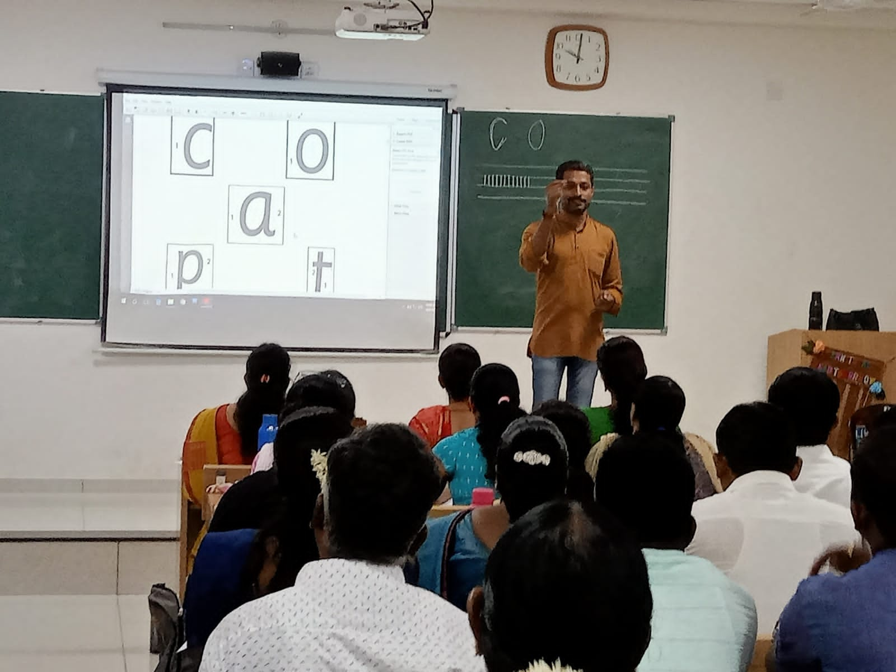

The RP Mr. Basheer demonstrated the activities on FLN LOs, its nature and activities. Groups were made to read the nature of the activities and given chance to present it to the whole class.
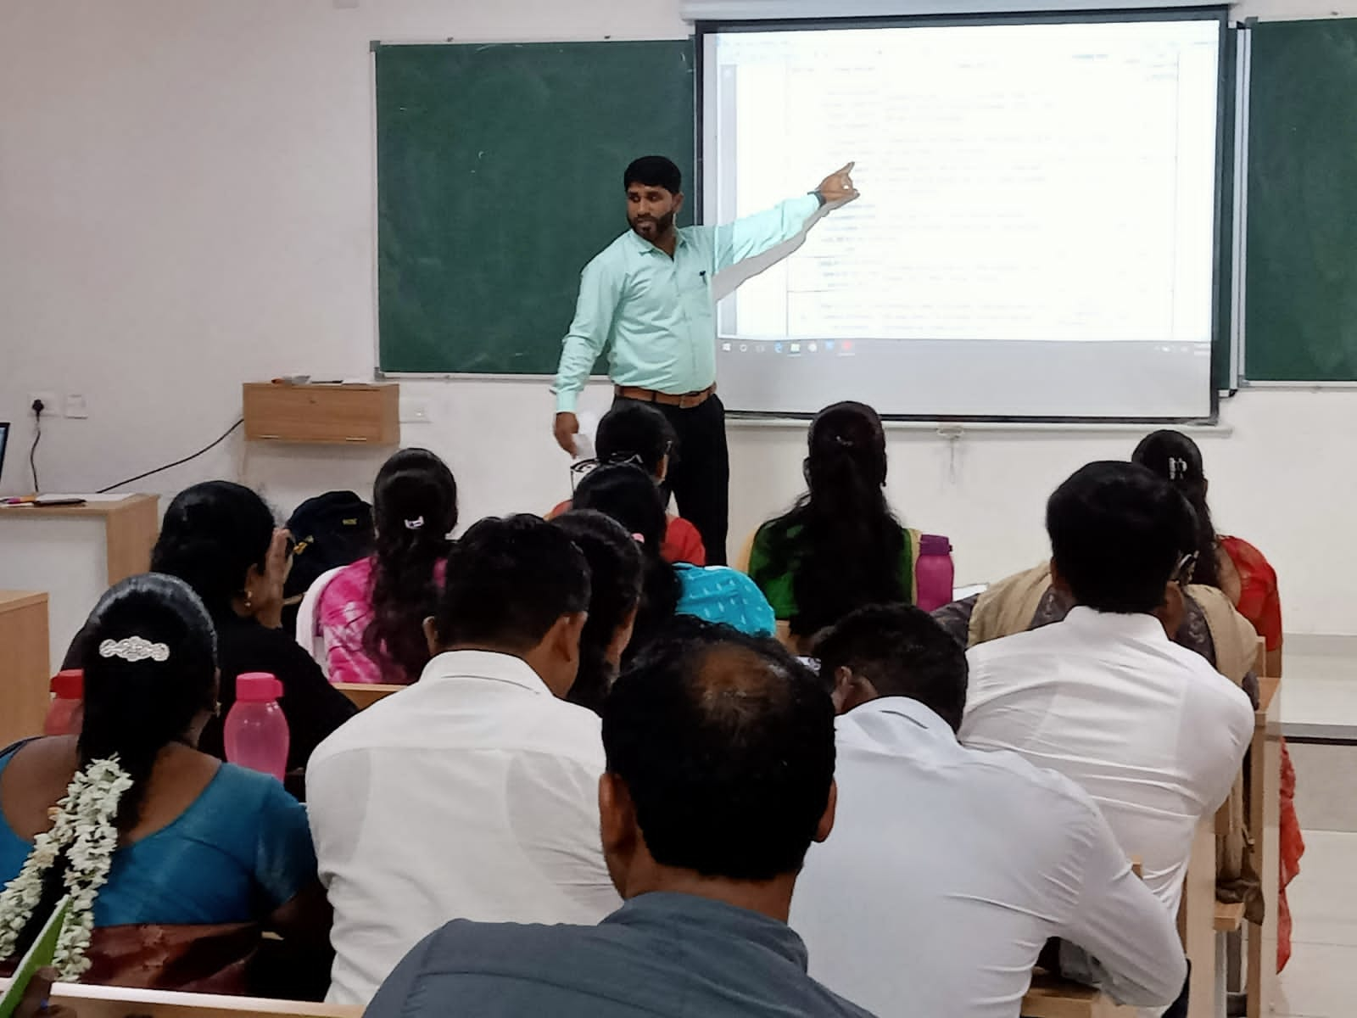
Ms. Priyanka Shamala took the class on how to do assessment of Class 4 and 5 English in Kalikachetharike program. And detailed discussions were made on the KC circular. Then all gathered in the hall for the valedictory function.

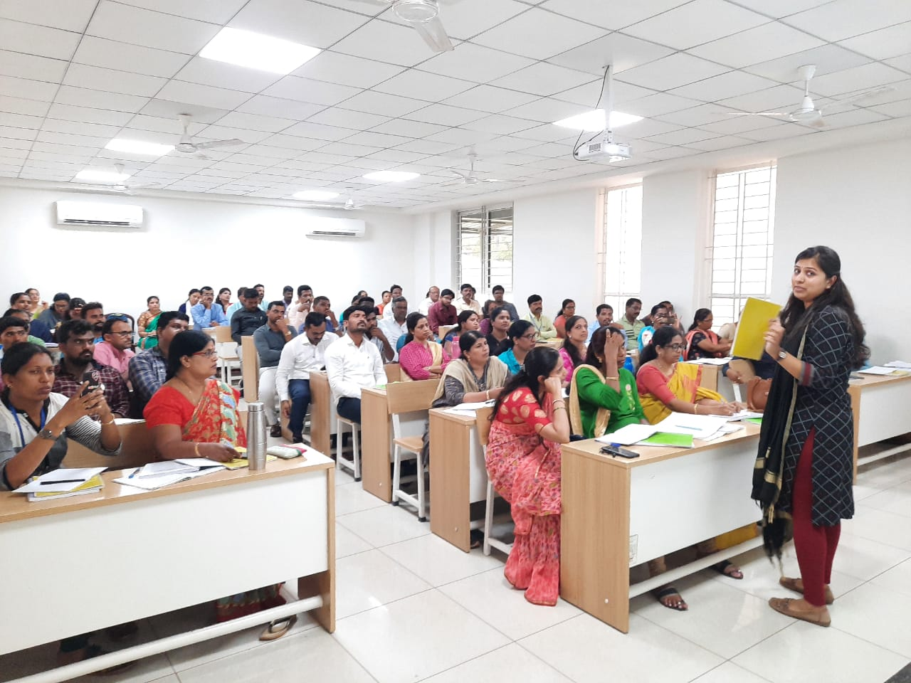

Class:6
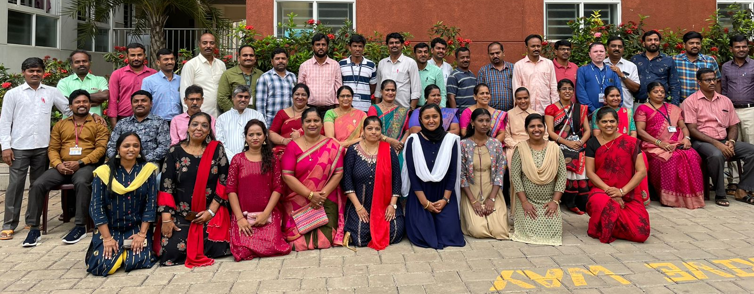
“The great aim of education is not knowledge but action."
The selected English RPs from all 34 districts completed a 3-day State level training Programme on “Kalika Chetharike”, the new initiative of the Government of Karnataka to recover the Learning gap among the students due to the after-effects of the covid pandemic and closure of Educational institutions. The training was held on 6th, 7th and 8th of April, 2022 at Shakth Residential School, Shakth Nagar, Mangalore. We had experts from Azim Premji foundation and MRPs from Dakshina Kannada who were involved in the work of Preparation of teachers’ hand book and Students’ Learnng book. The Class 6th, was led by four MRP’s, Ms. Swetha, Ms. Lydia, Ms. Shalet, Sr. Jishi guided by Mr.Ramachadra Giri of Azim Premji Foundation.
Day 1
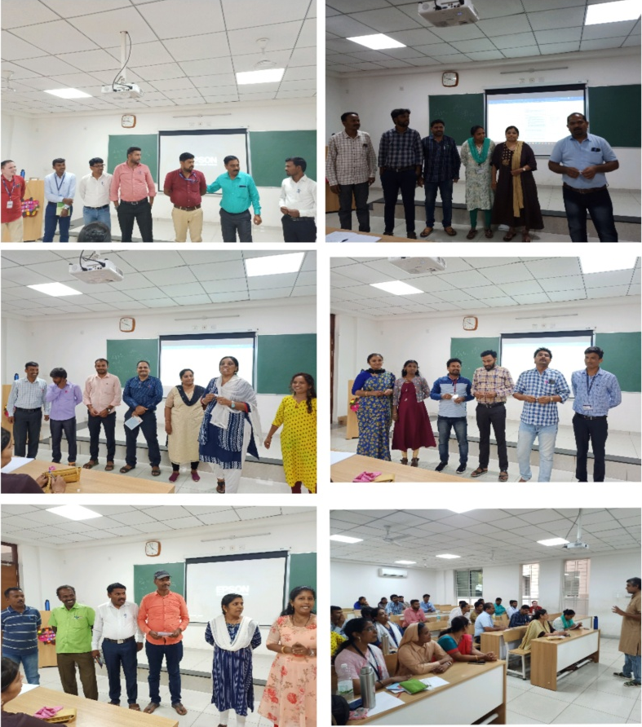
First session was taken by Sri, Ramachandra Giri, from Azim Premji Foundation. He briefly explained about:
* What is Kalika Chetharike?
* Meaning of Kalika Chetharike.
* Purpose of Kalika Chetharike
* Importance of Kalika Chetharike

He explained Kalika Chetharike is based on learning outcomes. The learning outcomes selected from the previous and current academic year of each grade and only most important and top prioritized Lo`s are considered. He explained that Kalika Chetharike should be carried out throughout the year. It is like extended bridge course. It is the responsibility of the teacher to carry it out in effective manner, taking into consideration that Pupil get the best results finally at the end of the year, by bridging the Learning gap and we could confidently say that “Chetharike /recovery” has taken place among all the students.
KALIKA CHETHARIKE=FLN + LO'S OF PREVIOUS ACADEMIC YEAR+ LO'S OF PRESENT ACADEMIC YEAR. LOs are more important than the text book/ syllabus. In Kalika Chetharike,Text books will serve only as a reference book or a supportive materal. Based on Lo's a teacher can independently choose the activity of his/her own along with prescribed activities from the student workbook. After the lunch break, we gathered again and the MRPs carried out the ice breaking session and grouped us into 5 groups namely Blingualism, Phonics, Alphabet, Punctuation and Vowels. Then we were giving LO chits to develop activities including teacher instructions and present t to the batch in groups. We worked in our respective groups and got a hand-on experience on developing activities and teacher instructions based on the selected learning outcomes.
Then the MRPs briefed us about the 10 learning outcomes of class 6 along with the associated NIPUN Bharath learning outcomes, the textbook reference and the time frame to carry out the learning outcomes. The MRPs even enlightened us about the approaches adopted in finalizing the learning outcomes, rationale, design, arrangement of activities etc. At the end of the day 1, we were given the teacher handbook and the student hand book and were asked to go through the material. Though tired, we got answers to many questions on day 1 but yet many are there to be sorted out. Waiting eagerly for day 2.
Day 2
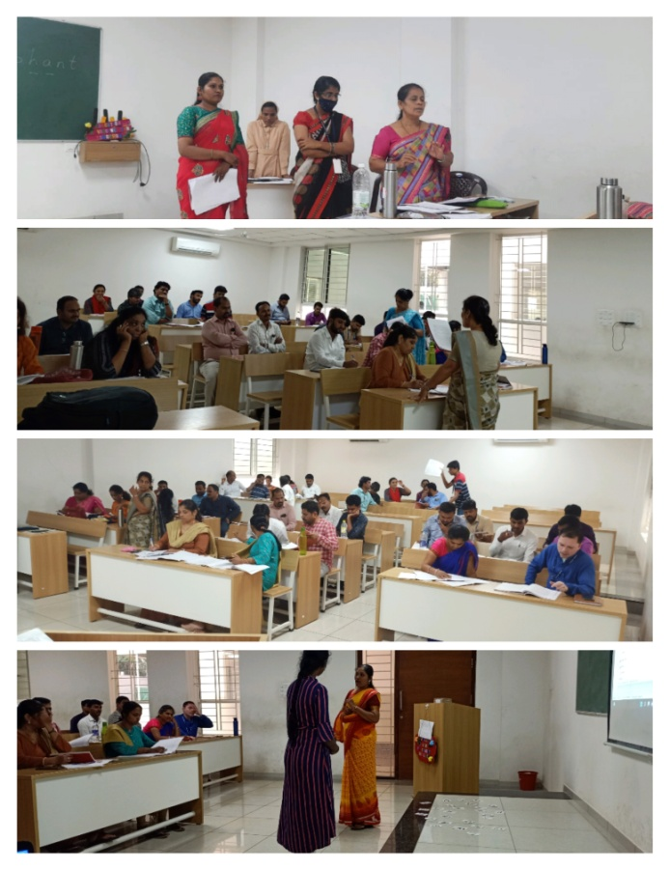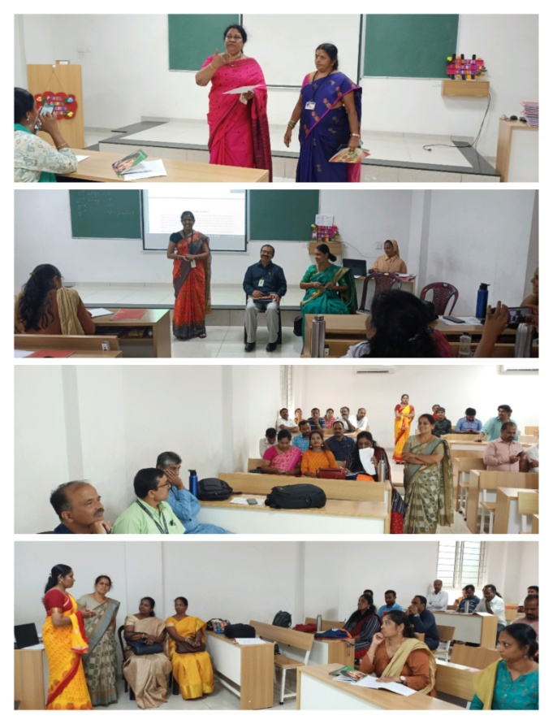
After the morning reflection session by all the groups, The first session of the second day the demo of Learning Outcomes commenced. The demo was given by Ms. Lydia, Ms. shalet, Sr. Jishimole and Ms. Swetha. All these MRP's selected the first learning Outcome:- “Recognise the letters and their sounds, frame simple words with the help of given clues, and get familiarized with sight words.”
They had designed and demonstrated activities to achieve the desired outcome from the trainees to reach to the students. The demo made us understand the use of teacher handbook in a very effective manner. After the Demo MRP’s asked the trainees to give constructive feedback. We got a clear idea of using or giving constructive feedback.
Second session of the day 2 was taken by Mr.Ramchandra Giri Sir of Azim Premji foundation. He dealt about "A note to the teacher". It was a detailed session and was presented aptly, which gave proper inputs for us about what actually has to be done in "Kalika Chetharike" and detail understanding about the Purpose of Kalika Chetharike. He explained how the pandemic situation has created a "void" in schooling. So, our Karnataka government has decided the academic year 2022-23 as the "Kalika Chetharike year which would focus completely on “learning recovery". He stressed about the additional challenge which most of our children face as they are less exposed or they no exposure also to the English language. The goals Foundational Literacy, as specified by NIPUN BHARAT largely cover all the 4 language competencies "Listening, Speaking, Reading and writing up-to a level that learner will understand.
While doing this, the teacher should keep a few important things irrespective of grades.
- They should explain bilingually.
- Involve students in the classroom activities.
- Learning objectives can be achieved using the activities provided in the Student Workbook.
- Learning Sheets in the students’ workbook can be used for both practicing and assessing.
He finally stressed about the importance of Constructive Feedback. He also gave a little hint about the Assessment which will be discussed on the last day. Before we dispersed to the lunch, we were given chits to give a demo of selected learning outcomes, by using SW and TH, after discussing in the groups. After lunch, we gathered in the classroom and witnessed the demos from two groups. And were again, became the part of fruitful learning of giving constructive feedback. The day should be kept as a memorable one, since honorable JD Mr. Cyprian, DIET Principal Ms. Rajalaxmi and other dignitaries from the DIET had joined us during the sessions and became guiding stars to us.

Day 3
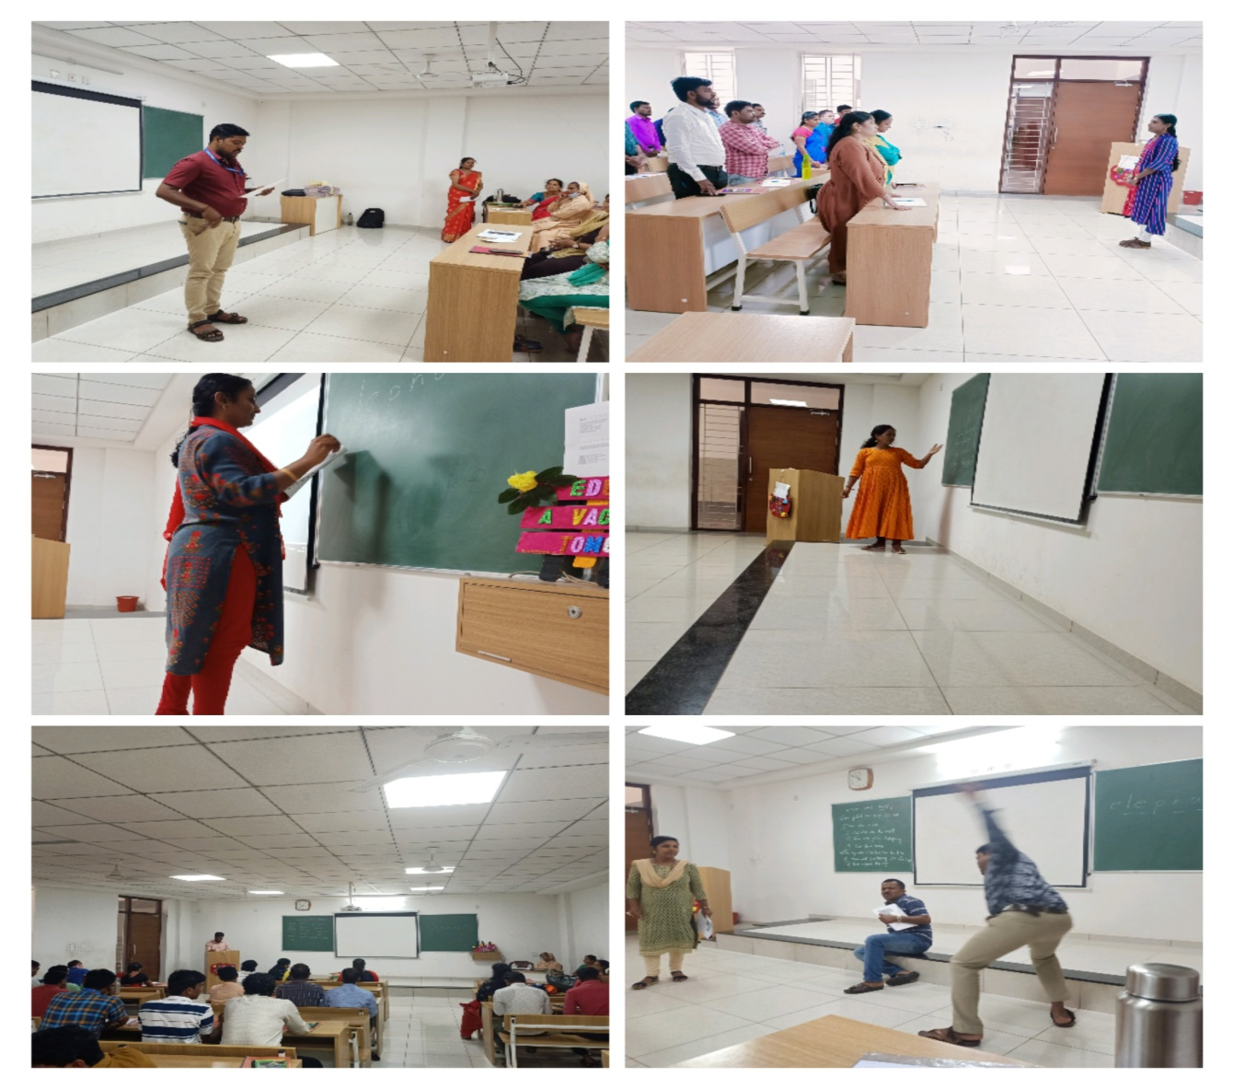
"A good teacher can inspire hope, ignite the imagination and instill a love of learning"
The day began with great discussion about cascading the content at districts and taluk level. All the resource people clarified the doubts and gave mind-mapping on how to cascade at district level. Phonics group was given the chance to present a demo on the learning outcome " Answer Coherently in written or oral form to questions in English based on day-to-day life experiences, unfamiliar stories." Participant Basavanappa presented Activity Sheet 1- Rearrange below pictures in an order and form a story. It was very lively and humorous presentation which made trainees widen their lips to enjoy and learn through play way method. Resource person Flavia D'souza gave a demo on Activity sheet 1:1, Look at the picture and answer the questions. She did a mimic of the pictures which were shown in the book. The elicited answers from the participants and made them Comprehend the situation. "All 5 groups gave their constructive feedback to the aforesaid resource persons.
All RP’s also provided great constructive feedback to the aforesaid Resource Persons, RP Swetha briefed us on the Learning Outcome "students introduce themselves and speak about their surroundings". Swetha maam cleared most of the doubts in the activities of the above said learning outcome. The next session began soon after the delicious lunch. The MRPs Swetha Ma'am along with Lydia ma'am, Shalet ma'am and Sr. Jishi had given the Lo's to each group to present the demo class. The members of vowel group demonstrated a class on the learning outcome 6.3 that is "Students respond to simple instructions and announcements". Kavitha madam gave instructions to the trainee teachers and all responded to her simple class -room instructions. Kamraj sir made us to mime the instructions we observe in public places and asked others to guess the action. Saheb Gowda sir conducted “simon says” game. Later the team 'Punctuation' came forward to demonstrate a class on the L.O. 6.5 i.e. "students use the simple parts of speech in meaningful sentences. Shastry Krishna Murthy sir from Punctuation group demonstrated an activity about preposition using the Pen caps to show the position. Bharathi Maam enriched the class with "Laddu chor activity and briefed us about personal pronouns. Shalini maam asked us to list the things find in the class and also to name animals, place and bird names beginning with initials of our names. With this she briefed about nouns. The constructive feedback was elicited by the other groups after each group's demo class Even the R.P.'s spoke about the areas of improvement in the given demo class.
Reflection: All the participants enjoyed. It was more of play way rather than achieving the learning Outcome.
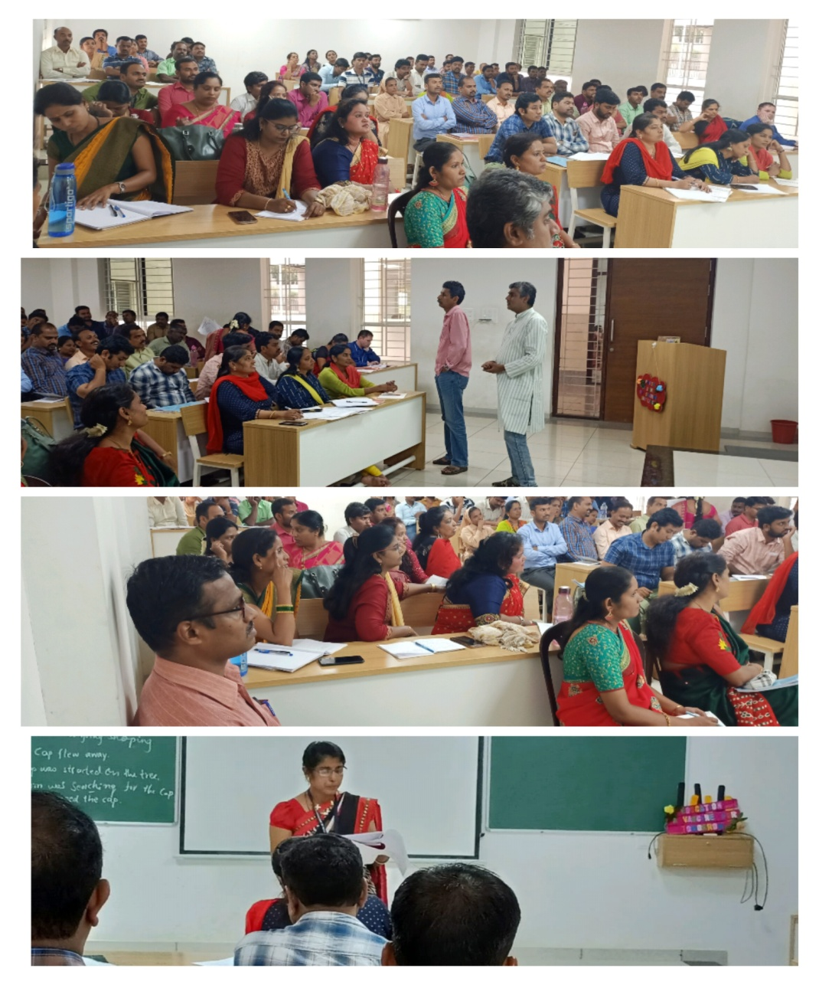
After a short break, we assembled again in the training hall. The class 7 trainees had joined us for the joint session on Assessement in Kalika Chetharike. With the help of PPT presentation, the MRPs gave a thorough picture on the Assessment method to be carried out during the Kalika Chetharike year 2022-23. They briefed us about the diagnostic test, formative assessments, and summative assessments. We came to know that first semester consists 70% of previous grades Los+30% of present grade Los and the second semester would consist 70% of present grade Los +30% previous grades Los. With new hopes and a great responsibility, we all bid farewell to each other at the end of day 3.
Overall Reflection of the training: " Kalika Chetharike - The best project framed, organised in systematic way by the Education department is a wonderful step by the Government of Karnataka to fill the Learning gap among the students caused by Covid-19 Pandemic . It is a bold step taken by our department and it should be fruitful as all the teachers imply the same in their class rooms. A resource team worked behind it which is clear and easy in cascading and carries out with the children. Both the students learning recovery manual and teachers’ manual are very useful. It is organized systamatically. Definitely, this coming academic year will be a year of learning recovery for the pupil. It is a wonderful revolutionary Step and we RP’s., assure to the department this will be cascaded in experiential pedagogy to the teachers.
The trainee teachers who gave demo classes were all excellent with their presentation. We all got to know the different pedagogies of the teachers, from all corners of our state, but the classes could have been better with prior preparation. The feed -back session was little lengthier than required. All three days, we conducted several activities and demo lessons and also would spend a few minutes reviewing the lessons and the feedback from the teachers and MRPs. We are happy to say that we have received great input in these three days and each teacher was grateful for the learning they received. And we are enthusiastic that we would try our best to recover the learning gap among our students. Overall it was great session in enlightening ourselves and preparing our groups in carrying forward to the great March. Thank you.

CLASS 7
Day 1
Before going to lunch Mr. Vijay Kumar, RP, discussed about the Education before and after COVID, he continued the session with question and discussion about study gap of 18 months. Trainees pointed out many things about child behavioral changes. Then he explained the need of KalikaChetaharike upakrama in every class. He introduces the topic of KalikaChetaharike Upakrama 2022-23. After the session trainees had lunch.
Then session continued in different classes and we came to 7th standard group. Our MRP Smt. Flavy Fernandes started the session with a song with her sing song voice. Then Mr. Santhosh Misquith, Continued the session by introducing trainees with an ice-breaking session. Afterwards class was divided into 5 groups by picking the chits, like Alphabet, Bilingualism, Phonics, Rhymes and vowels. Then Session continued by Mr. Benny Mathews about need of KalikaChetaharike Upakrama in English language. He discussed about Learning Outcomes of English language and give the clue about KalikaChetaharike upakrama's 11 LO's.
There after having Mangalore special Golibaje and Tea. Mr. Benny gave activities to create conversation to trainees to do in group. With the happy note, we ended up our day with lots of confidence.

Day 2
Good morning everyone present here. My name is Bibin, reading yesterday’s training session’s report. On 7th April 2022 the training had started with daily report presentation session which was presented by different groups.Mrs. Kumudhini of vowel group,Sang an enthusiastic rhyme called as chai.. Chai.. Coffee.. Coffee which had a perfect rhythm and action,she also sung a prayer song. Thought for the day by Mr. Sharanu And report read by Mr. Dhareppa Which was precise and covered most of the important points.
Soon after the report reading session Mr.Benny, APF, started reflective session of the previous day, during this session he emphasised on learning outcomes, importance of learning outcomes and teacher's instruction. Later Mr. Santhosh, resource person KC, distributed the teacher's handbook and student’s work books to all the participants.He distributed the Learning outcomes in 5 different groups and asked them to read the Note to the Teacher from the teacher’s hand book in detail and to present the same, by this activity he made us to understand the importance of teacher’s handbook, students work books and learning outcomes. He continued his session by demonstrating one of the activities from the student’s workbook, in this activity he acted as a 7th std English teacher and all the participants acted as the students.The session was very helpful for all the participants as there was a proper connection between the teacher’s hand book and students work book. The next session was continued by Mrs. Savitha, RP. She also demonstrated an activity from the student’s workbook and explained the importance of giving proper instructions before any language activity.
By this demonstration session we got an overall picture of Kalikachetharike training and handling of modules. As it was an interesting session, we didn’t bother about our lunch time, it was almost 1.40 pm.
After a delicious meal we all gathered for the afternoon session, Mr. Santhosh divided the whole class into 5 different groups and all the groups were assigned with different activities from the students work books and all the teams were asked to demonstrate the same. For this activity 45minutes were given for the preparation. During this time all the groups looked active and the resource persons monitored each group and cleared their doubts. By the end of the day only two groups were able to give their demonstration. Overall, it was a fruitful day, most of our doubts regarding the modules were cleared by the arrival of the modules and timely interaction of the resource persons.
Day-3
Report of Third day report presented by group-5, Alphabet Mrs. Gladys miss lead us into prayer. Report of day 2 was presented by Mr. Umesh. Mr. Lakshmikanth gave the thought of the day.The first day session was started with the demo by group no-3, LO7.5 they began with the Lion and mouse story. And continued the demo. Group no- 4 presented the demo with nice and apt TLM’s. group no-5 presented the LO-7.8. the SRP’s gave the necessary feedback. The last session was in general regarding assessment. This session was conducted by Mr. Ramachandra Giri, APF. He discussed the following points.
- NEP-2020 competency-based Education and Learning.
- Focus on effective learning.
- What to assess.
- Nipun Bharath Los.
- How to asses’ students for SA-1, SA-2 and FA’s.
- CLASS: 08
After lunch all the participants have been divided into different groups asked to assemble indifferent classes. RPs for class 8thhave assembled in the class room 7. MrDileep Kumar, MRP welcomed by introducing himself to all and got everyone introduced. He started discussion aboutkalikachetarike in detail. Participants were divided into 5 groups to transact the programme by small activity. After the tea break, Mr Abdul Latheef.C MRP once again stressed the importance of the programme and the role of the teacher to implement this programme in school level. He also stressed on the need of to fill the learning gap due the covid pandemic. He also taught about the different Learning objectives of class 6, 7 and 8. Then, Mr.DileepKumar.S had given selected learning objectives to the different groups and instructed the participants to frame some activities also to write some teacher instructions for those activities. Participants were started to work on given task. After the completion of the task, they were presented their works. All the MRPs have given proper feedbacks. By this first day was ended.
DAY-02

Second day training programme was started with the reflection of the previous day. It started with prayer of first group.Then participant of the second group anchored the programme. Third group members presented the thought for the day, which touched everyone's heart. Group members of the fourth presented the previous days report. Fifth Group members were conducted the language game which was 'DIAMOND VOCABULARY & which is helpful for all the children. After that all the members of the group participated in their respective activities. Then, Mr. DileepKumar.S has given a demo on activities on some Learning Outcomes. He has chosen debate. All are participated in this activity. He has given clear cut information about conducting activity and evaluation of those activities in the classroom.
Soon after this, one more activity was conducted by Mr. Vijay kumar has given a demo on another Learning Outcome activity i.e. critical thinking. After that he asked some questions to the participants to elicit the answers. He gave more information about critical thinking. Then he distributed student’s workbook and Teachers handbook to all the participants and instructed to refer those materials carefully.
Then Mr. Abdul Latheef. C started to discuss on given materials. He also clarified the NIPUN BHARATH Learning goals. He also encouraged participants to give demo on activities given in the student’s workbook. All participants were actively participated in their activities. MRPs have given suitable feedbacks wherever necessary. Then Mr. Vijayakumar assigned the third day activities for the participants which was based on Learning outcomes. The day was ended with this activity.

DAY-03
The third day of Kalikachetharike training programme was begun with reporting of previous day interactions. The participants share their opinions regarding the learning outcomes and the activities which will be helpful to recover the learning loss among the students. They also share their views on different learning activities which are suitable for three levels of the students in the classroom.Days first session was engaged by Mr RamachandraGiri from APF on the topic of Assessment. The session is concentrated on different types of assessments - diagnostic formative and summative which are being used throughout the year.
The participants discussed on the process of assessments like preparation execution and giving, feedback to the learners. Later the days program continued with the demo classes by the participants on the selected learning outcomes which they have taken in the previous day.The feedback from other participants and resource persons lost helpful to all to know about competency based learning program for KalikaChetharike. Later, there was a general discussion on foundation literacy skills. The discussion was helpful to know the integrated skills from lower grade to higher grade. After that the design and process of cascading the training programs in their respective districts were discussed and a time table was prepared.
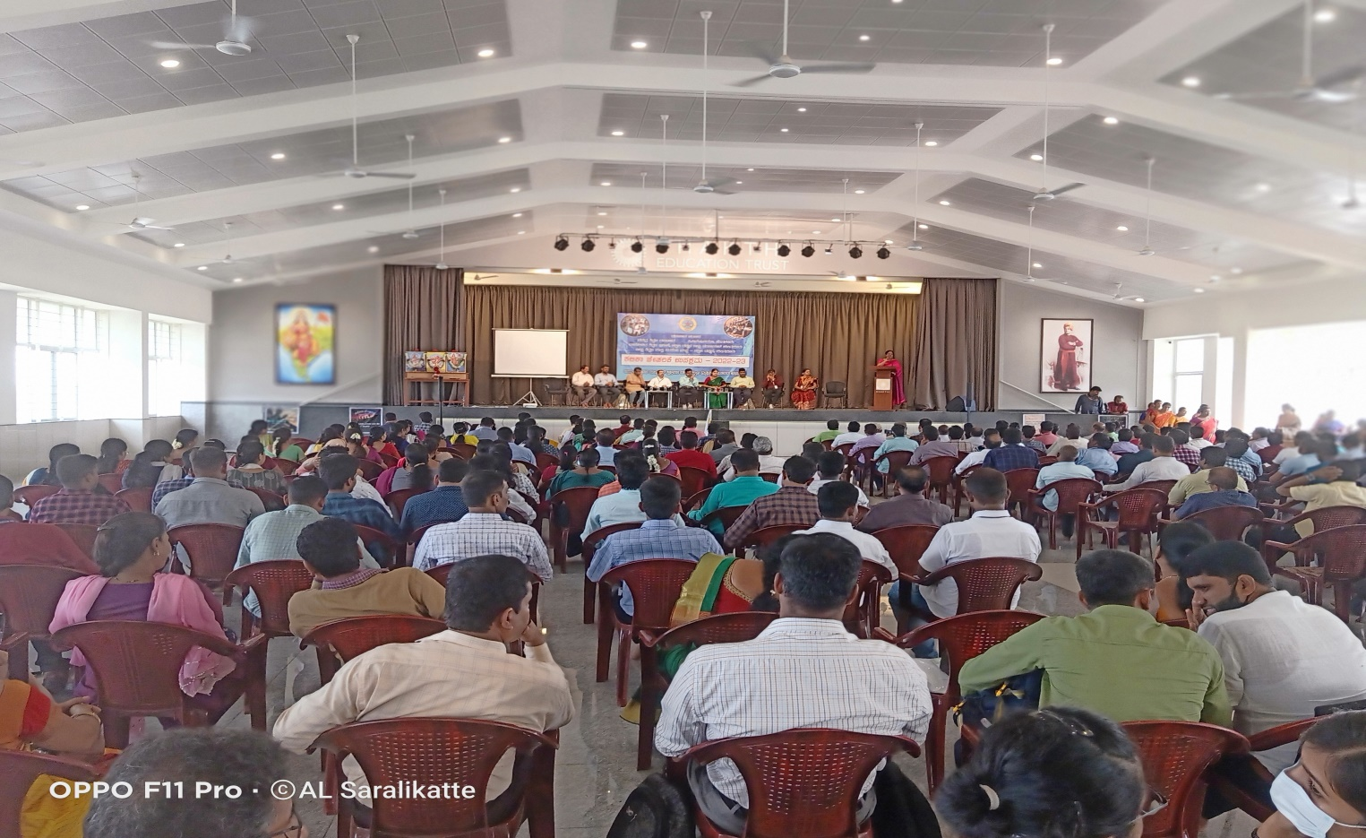
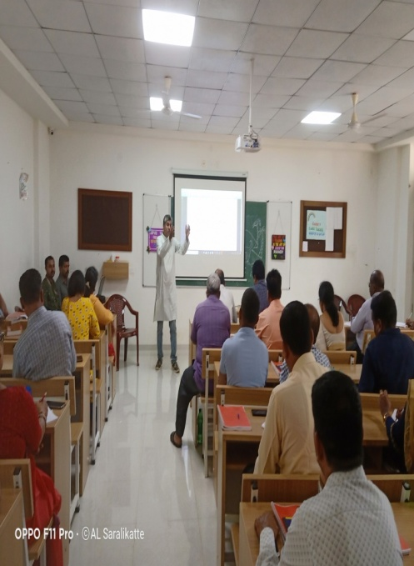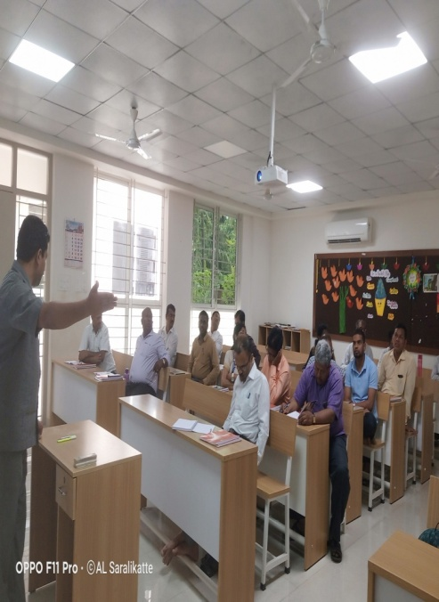
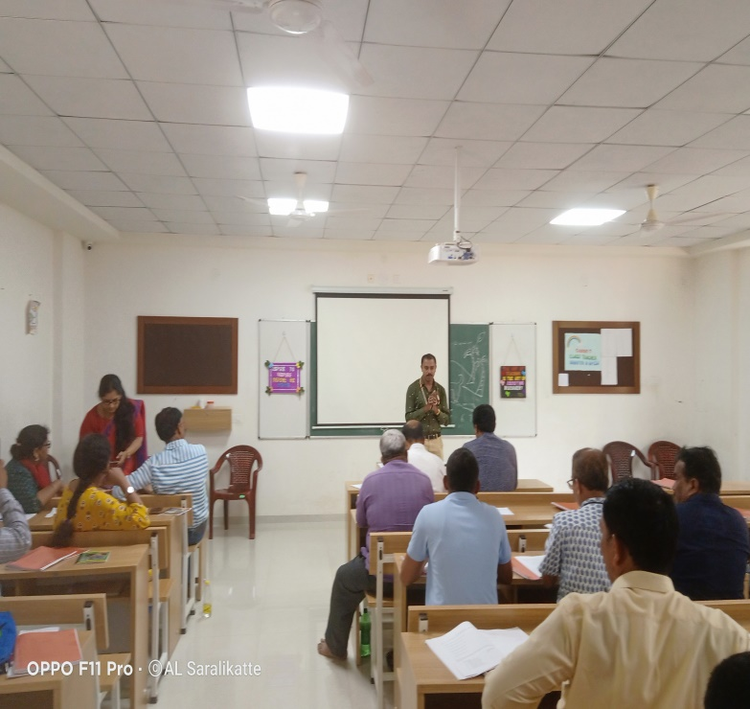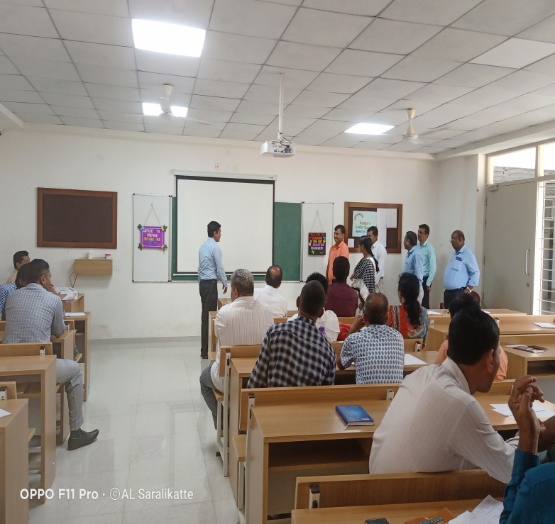
Class 9
DAY-1
“ KalikaChetharike’ a new programme for the next academic year 2022-23. It will be introduced to enhance critical thinking and discovery based learningamong the children who are promoted to the next class without examinations and deprived of formal education in schools. The curriculum has been prepared by the subject has taken the initiative of preparing the modules for English Language leerning.
As per DSERT guidelines, three days training from April 6th to 8th was organised in Shakthi school, Shakthinagar Mangalore D.K. DIET.On 6th April 2022, statelegal English RP’s training was inaugurated by Dr. Cyprian Montero, J.D. and Principal of CTE Mangalore. He addressed the State level RP’s gathering and said that D.K. DIET has done a tremendous job in preparing the resource materials and worked hard in organising training for state level RP’s. The dignitaries on the inaugural stage programme. Mr. Sudhakar DDPI, Mr Ramchandra, Azim Premji foundation, Mr. StanyTauro, President HS Teachers Association, Pruthviraj ,The Principal of Shakthi School, Mr PrakyathRai ,and Ramesh administrative officers ,Shakthi School wished a great success for the programme. Mrs. Geetha Shetty, Nodal officer of KalikaChetharike, D.K. DIET has successfully organised the programme.
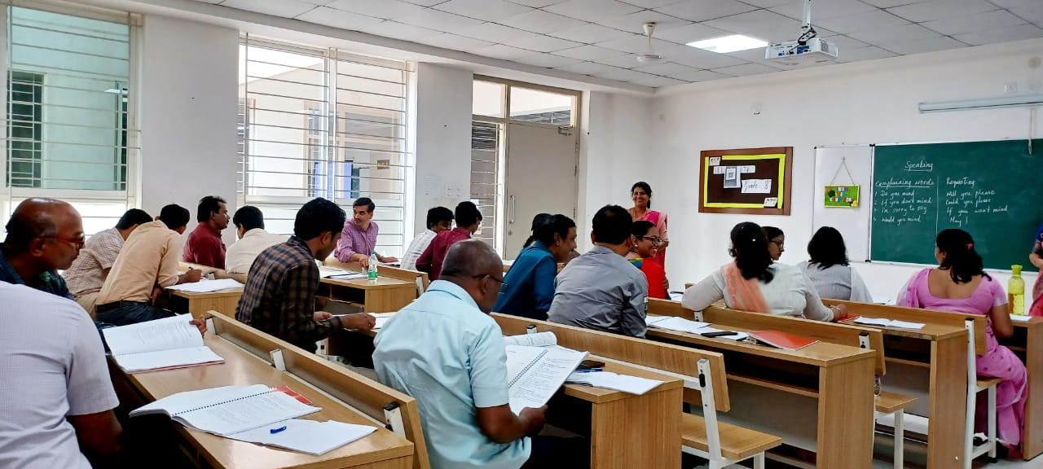
Soon after the inaugural ceremony a general session was organised by MRP’s Mrs. Sumathi and Mr Vijay Kumar The Session was to understand the basics of ‘KalikaChetarike’ Several questions were raised by the RP’s such as ‘What have been trainees observation regarding student learning since schools have reopened in Nov 2021. What is the role of a teacher to help the student to achieve FLN competencies and the basic learning outcomes for the learning recovery required for the current grade. The different approaches – prioritizing learning out comes Mapping LO’s with syllabus and textbook and suggesting pedagogical practices to fill the learning gaps in English. After the general session MRP’s have made groups class wise and organised training class wise separately. The MRP;s Mrs. Sumathi Bhat, Mrs. Vijaya K.R, Mrs Chaya Kini, Mrs. Radhika Rao, Mrs Geetha and Meghana Basuri from Azim Premji foundation.
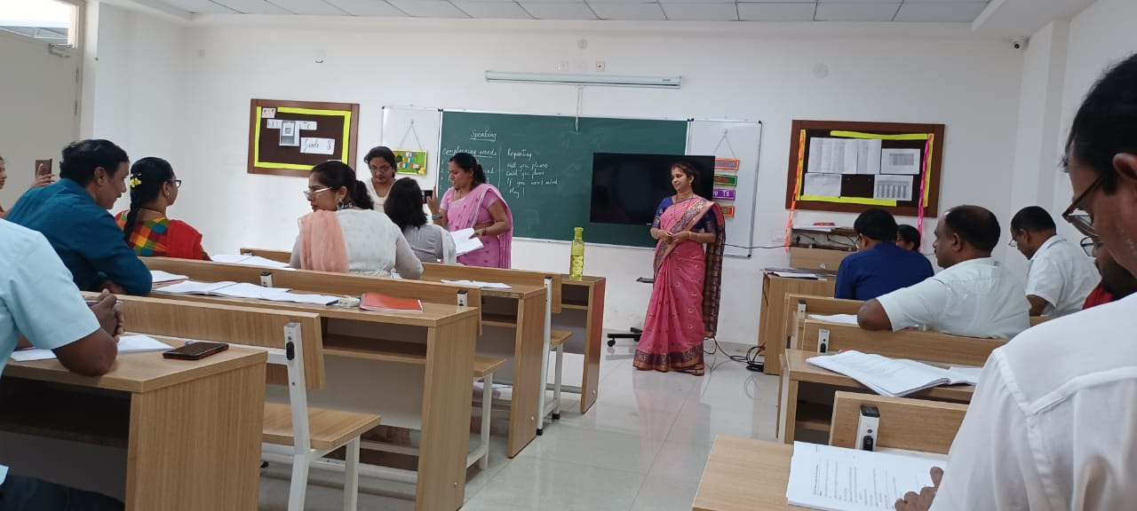
Mrs. Chaya Kini MRP, discussed the problems faced by the teachers while teaching English such as - less exposure of English, other subjects are taught in Language 1. unphonetic nature etc.Mrs. Vijaya KR MRP discussed about the different points and the pedagogical protection and LM, NIPUN Bharat (NB) LO’s etc.
Mrs. Vijaya KR MRP formed groups through an interesting activity. Each trainee was given a word on a piece of paper. They were given instruction to find out their group numbers. Trainee RP’s found out their groups by telling their words and made groups of adverbs, prefixes, suffixes, homophones, Rhyming words etc. After that trainee RP’s were asked to introduce themselves and using the word given to them in a sentence. The response of the trainees was excellent and co-operation of MRP’s were wonderful.
After the formation of groups Mrs. Sumathi R and Mrs. Radhika Rao introduced learning outcomes and each group was given a learning outcome to frame innovative activities based on that LO to teach in the classroom.. Trainee RP’s had discussed among themselves and presented activities for LO’s. The presentations were superb and the activities were easy and child friendly.Appreciation and Positive feedback were given by Mrs Sumathi. The day was ended with full of innovative thoughts and ideas shared by the participants of the groups. The teachers handbook module was distributed by the MRPs and asked to go through and share their opinions next day.
DAY-2
To fill the learning gaps among students and government has introduced a new program i-e , “Kalika chetarike”. The second day 7/4/2022 , of this training program had begin with mellifluous Prayer by Balappa Y.Chalawadi. A detailed report on the first day’s programme was presented by Mr. Shivanand from Udupi. Thought for the day refreshes our mind with uplifting thoughts. We need daily input of new ideas, wisdom and experience. We were really motivated with powerful thoughts on “Self Confidence” by our SRP Mrs Vijaya .K.R Madm. A session on ‘ listening skills’ was taken by our SRP Mrs Radhika S Rao. We listened a paragraph and were asked to list out the Airborne and waterborne diseases. She also told some mind blowing riddles and puzzles. It was really awesome.
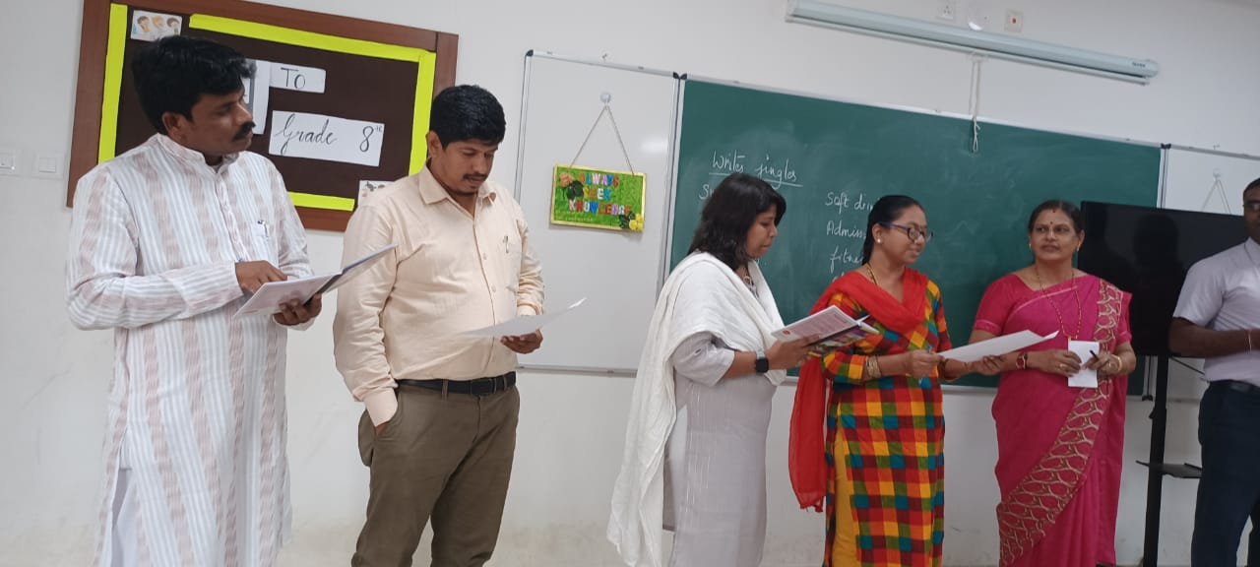
Later secession on ‘speaking skills’ was taken by our SRP Mrs Chaya Kini. The polite ways of complaining and different ways of requesting were been discussed. Each group was assigned to prepare the dialogue on same in different context. Then we presented our team work and gave feed back to others’ presentations. Finally we concluded that we can conduct such activities in our classrooms effectively. Another SRP Mrs Sumati R took the session on ‘ Reading skills’ .We were given some wrappers and were asked to note down about some keynote points. By this activity we discussed a method of reading ie: scanning. We discussed how this activity can make our student active in reading. In this session all the group members actively participated .
The the next session was taken by Mrs Vijaya K R on JINGLES. All the groups were asked to prepare jingles on various topics such as favourite snacks, shampoo, school, admission etc. After the refreshments we were assigned some of the LO s to work on . We were asked to prepare activities to present. We started it with a lot of discussions and ended with the best activities. After having delicious food we started presenting the activities involving all the participants. Each presentation was observed by all and constructive feedback was given. In this sessions all SRPs guided us to present and other participants encouraged us to bring out the activity effectively.

DAY-3
The third day 8/4/2022 , of this training program had begin with melodious prayer by Jyoti Chitradurga .Then thought for the day By Sharnu Sir . Later Uma ma’am presented the second day’s report Very confidently. Then we jumped into the session about the bridge course by Sumati ma’am. By discussing we came to a conclusion that the for the pretest for 9th standard and post test the question papers should be prepared based on the LO s of 6th standard competencies . The 7&8 th grade competencies are covered in learning sheets of Kalika Chetarike student learning sheets, 9th standard.
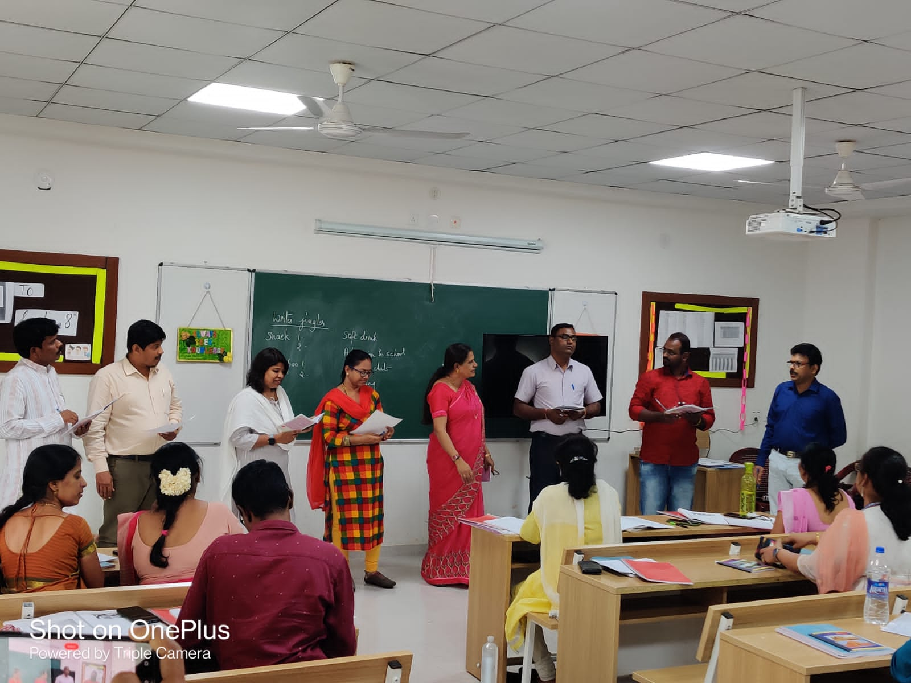
Next session was engaged by Mrs. Chaya Kini madam, “ analysis of Text book” . We were divided into groups to mapping the learning sheet activities with the text book activities. We discussed among us. Mrs. Chaya Kini guided us thoroughly. We found that to overcome the loss of learning, we need to take this Chetkarike. We should fill up the gaps with learning sheets.
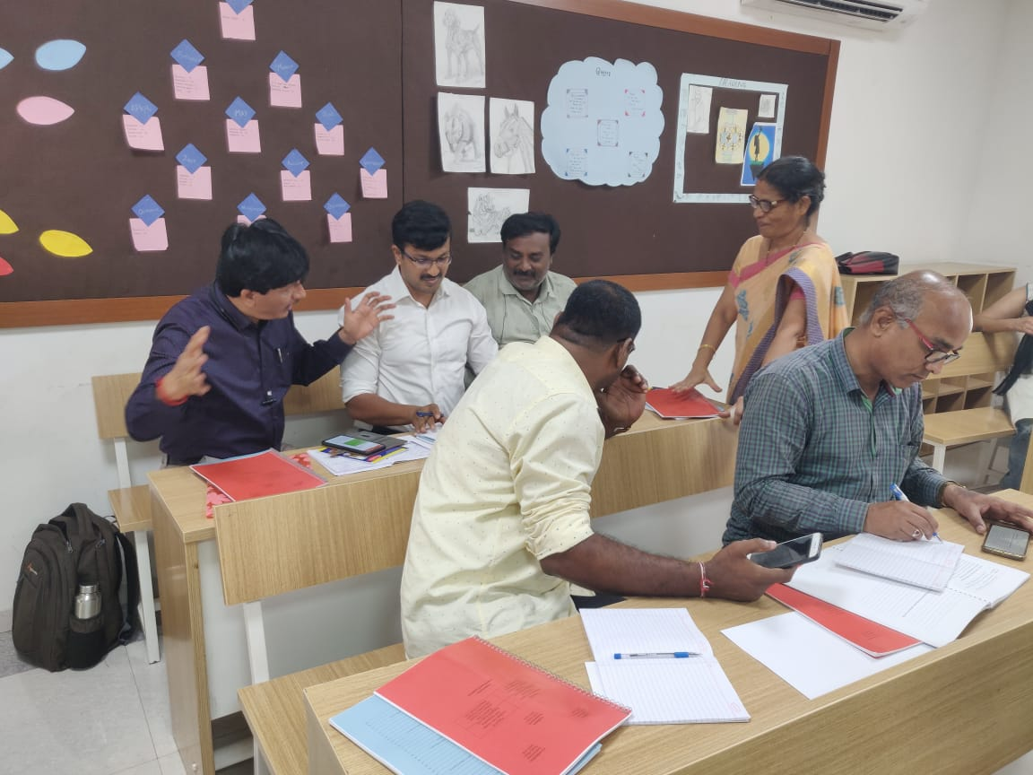
Later Miss. Meghna took the session. She dealt with assessment procedure to be taken under Kalika chetarike . She added that assessment is essential part of teaching learning process and documentation is also important.
In the evening at valedictory function, the participants share their views on 3 days Kalikachetharike training programme. They have shared their views and experiences in the training and how they are benefited with the training programme and they were capable to cascade the same.
